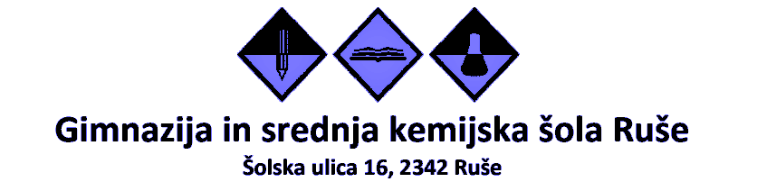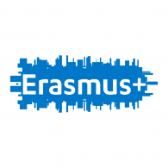

AKTIVNOSTI UČENJA, POUČEVANJA IN USPOSABLJANJA
Poljska, 21.10. do 25.10.2019

Nedelja, 20.10.2019 – potovanje na Poljsko
Odhod na Poljsko, čakajo nas dijaki partnerske šole II. Liceum Ogólnokształcące Gliwice in zanimive teme, aktivnosti.

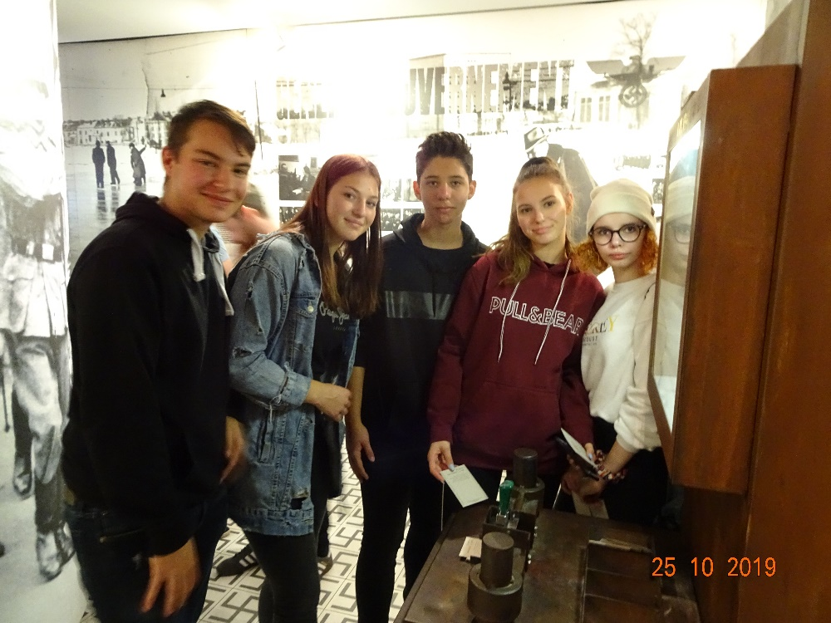
Luka, Mojca, Oliver, Ema in Ivana

Ponedeljek, 21.10.2019 – Propaganda kot vrsta manipulacije nekoč in danes, Gliwice
Dijaki GSKŠ Ruše z dijaki obeh partnerskih šol – III. Gimnazija Maribor in II. Liceum Ogólnokształcące Gliwice – začnejo z delom.
V delavnici, ki jo izvajata učiteljica zgodovine Mariola Trojan in dijak Kuba, razmišljajo o propagandi, spoznavajo njeno zgodovino, vrste, namen. Kakšno vlogo je imela v 2. svetovni vojni in pred njo?

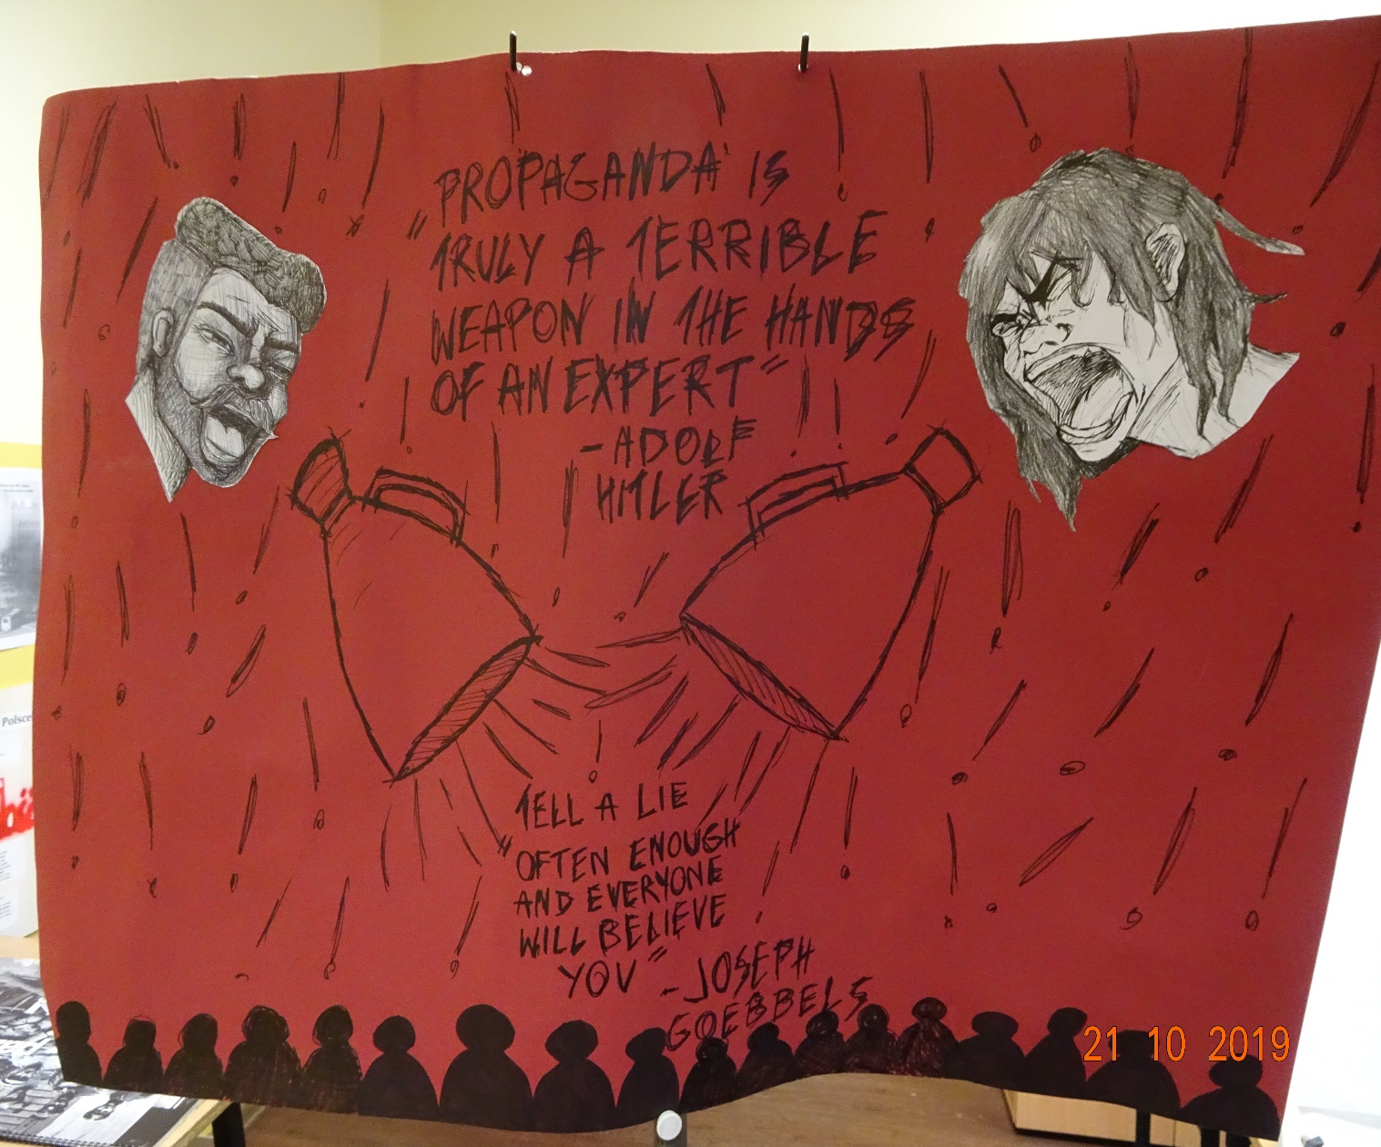

V besedilu »Education in the Nazi state« iščemo odgovore na naslednja vprašanja:
What was the main aim of education?
How many years of Nazi indoctrination did children get?
What was the role of teachers?
Were they compliant or did they rail against Nazi ideology?
Were the roles of boys and girls different? If so, how?

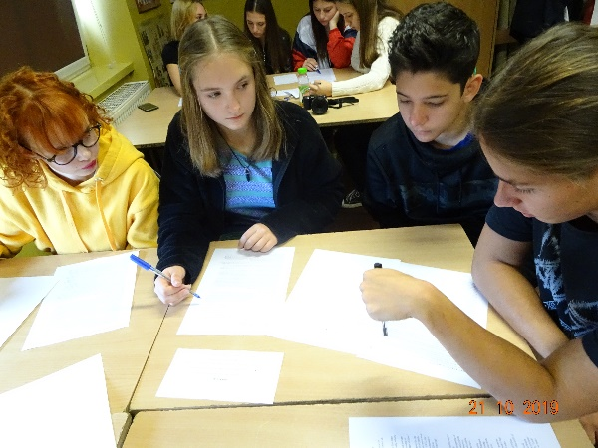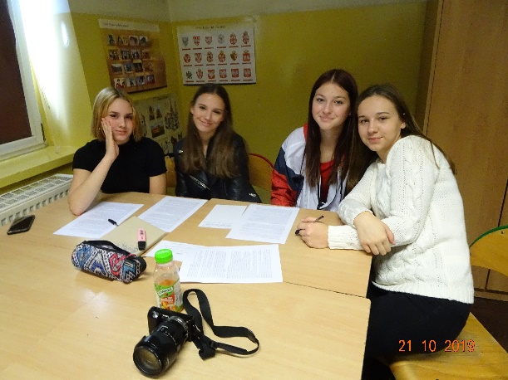
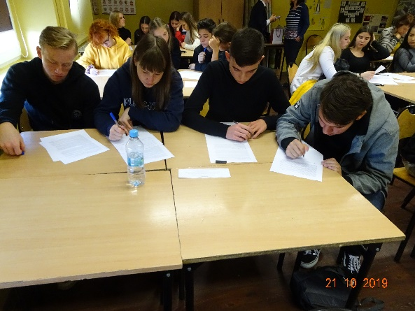
Spoznavamo zgodovino propagande, cilje, sredstva – propaganda v filmu, glasbi, na plakatih
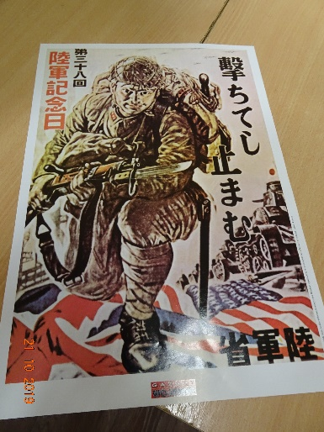

Kaj smo spoznali? Smo se kaj naučili?
Učiteljica Mariola in dijak Kuba predstavita rezultate po aktivnostih v zanimivi delavnici:
1. How do we manipulate people?
All the students put emphasis on the role of the politicians who use the media, posters etc. to make people believe in what they want them to believe.

2. Is propaganda still used today?
Most answers concentrate on such countries as North Korea and Russia, but during the classes it became obvious to everybody that propaganda exists even in democratic societies.

3. How do we avoid being manipulated?
Critical thinking was the most popular answer.

4. Why do politicians use propaganda?
Because it's the easiest way to gain popularity.

5. Is propaganda bad in any way?
Students understand that sometimes propaganda is used to achieve a positive result e.g. when it motivates us to help people in need, especially during wars.

6. When is propaganda used the most?
Students emphasise that wars and general elections are the best background for propaganda.

7. How did propaganda spread in the Ancient times?
The majority of students pointed out the significance of speeches made by politicians at the Assembly in Athens and the role of plays at the theatre aiming at creating a politically aware citizen.

8. What does propaganda thrive on?
Poverty and the lack of good education are most often used as the fuel for propaganda.

9. Can we ever put an end to propaganda? How?
Some students believe that to some extent education can solve the problem of propaganda but the majority of students is sceptical about it.

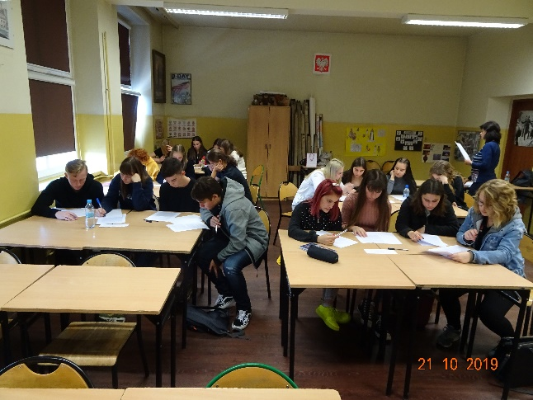

Na sprehod v Gliwice - spoznavamo zgodovino kraja, znamenitosti, srečujemo ljudi
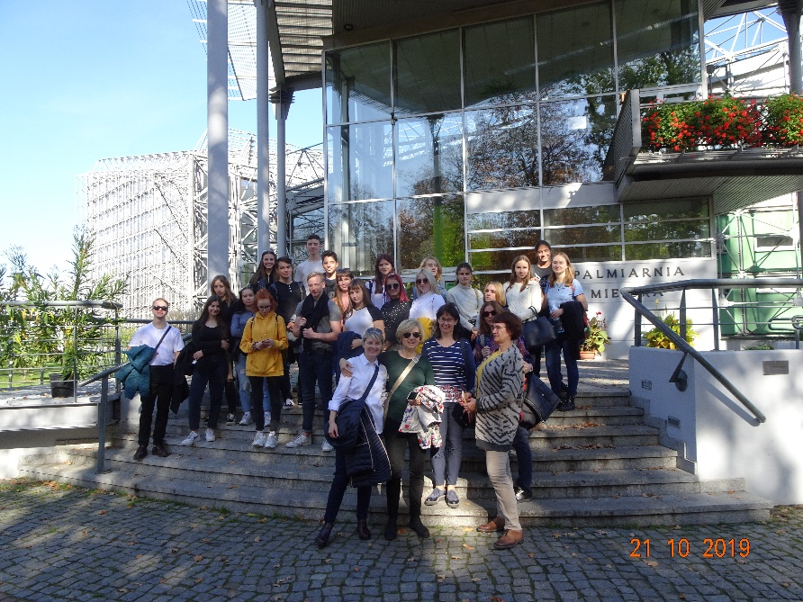

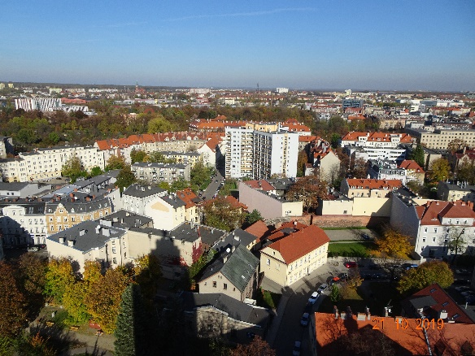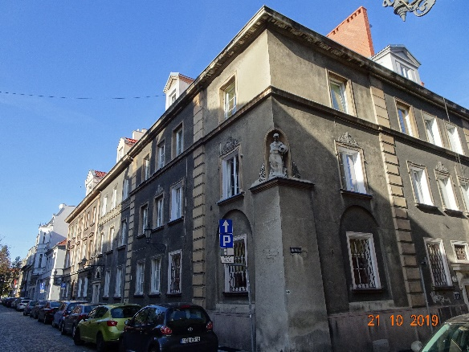

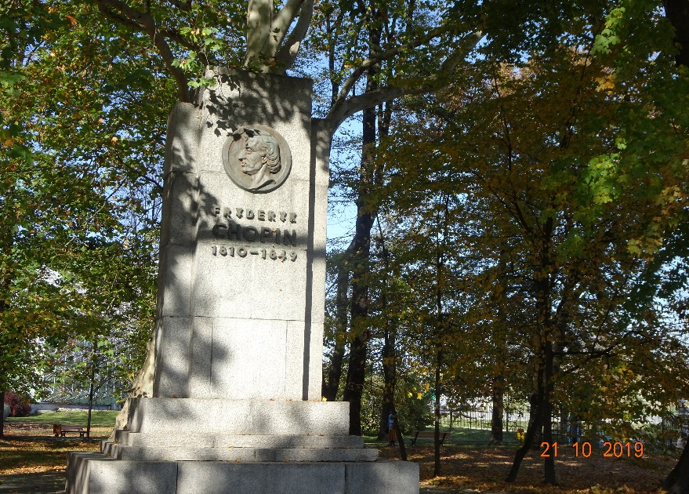

Torek, 22.10.2019 – Auschwitz in Birkenau
Pomembno je, morda danes bolj kot kadarkoli, da smo tukaj:
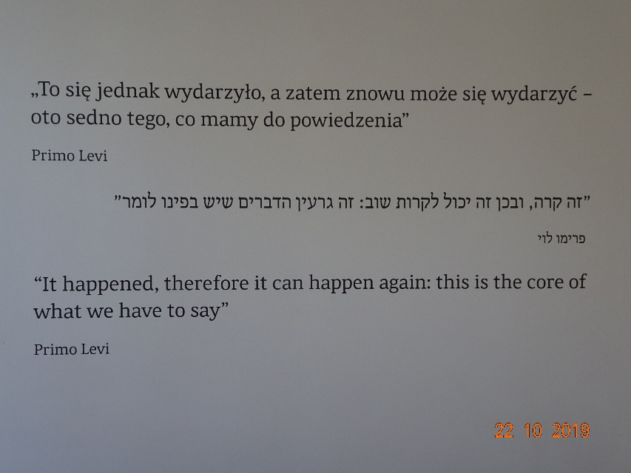
Slike povedo vse, zgodbe ljudi se nas dotaknejo.
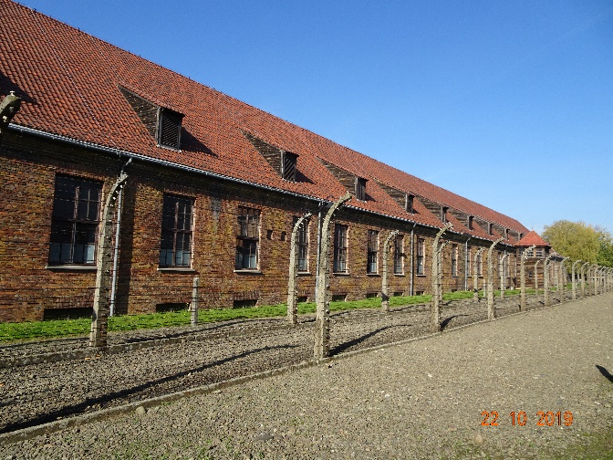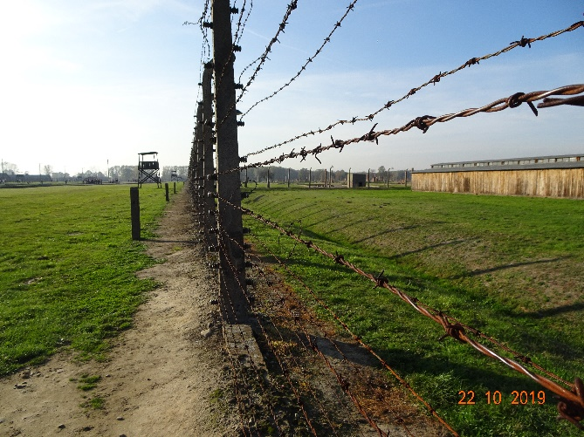
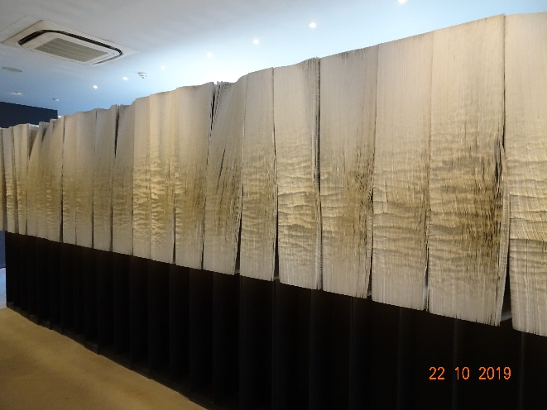The Book of Names

Sreda, 23.10.2019 – Manipulacija, komunikacija, družina; vloga propagande in lažnih novic v povodu za začetek 2. svetovne vojne; življenje Judov na Poljskem
Spoznamo »Still Face Experiment«. Pravila v družini? So pomembna? So manipulacija? Kaj pa nasprotja med pričakovanji staršev in našimi željami?

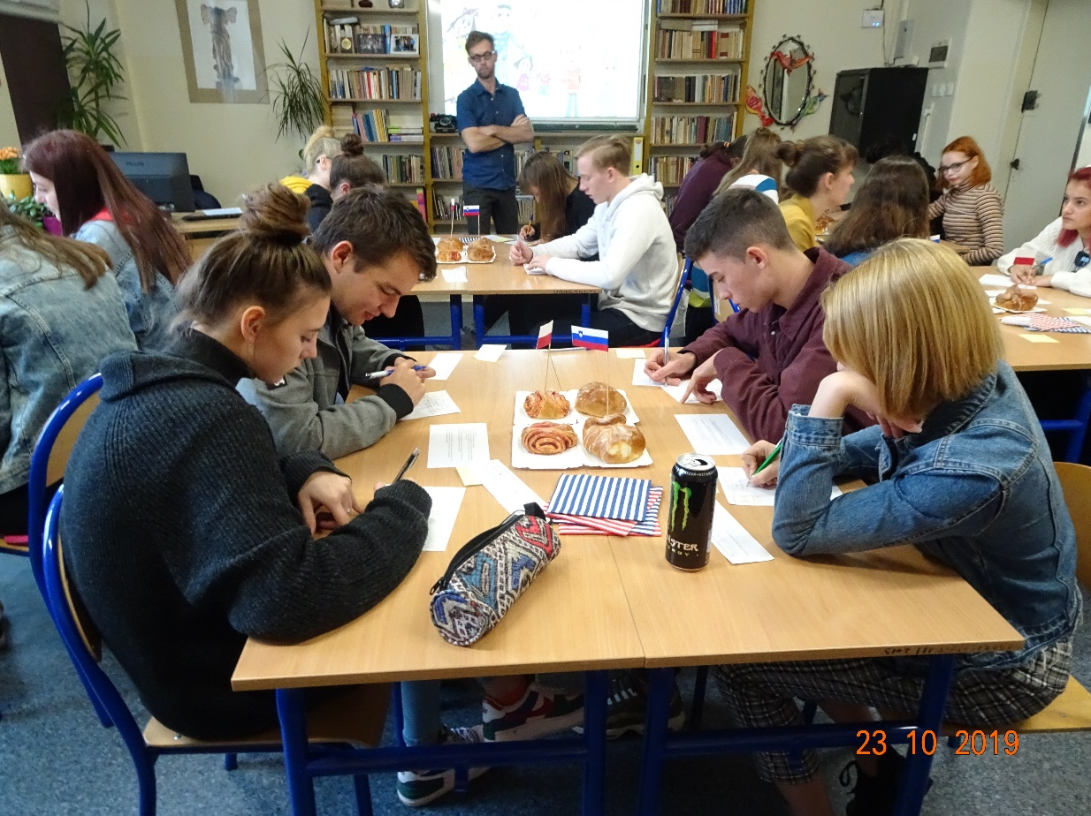

What actions make your parents happy, proud of you? What upsets them, makes them angry with you?
Talk to your partner. Important: safety rules – how do you feel? Are you comfortable?
YOU CHOOSE WHAT YOU WANT TO SAY. BE SUPPORTIVE, SHOW ACCEPTANCE, ALSO TO YOURSELF.
Po aktivnosti pa nas zanima:
How do your parents influence your behaviour? How do they make you behave, in the way they expect?
What do you think about your parents` rules?
Kaj pravi “mentimeter”: wish the best…, make me.., should be obeyed…, compromise…, cut my pocket money…, stress…, communicate…, trust…, boundaries…, extra chores…, discuss… .

Obisk radijske postaje – muzeja je priložnost za spoznanje, da lažne novice niso izum sodobnega politika:

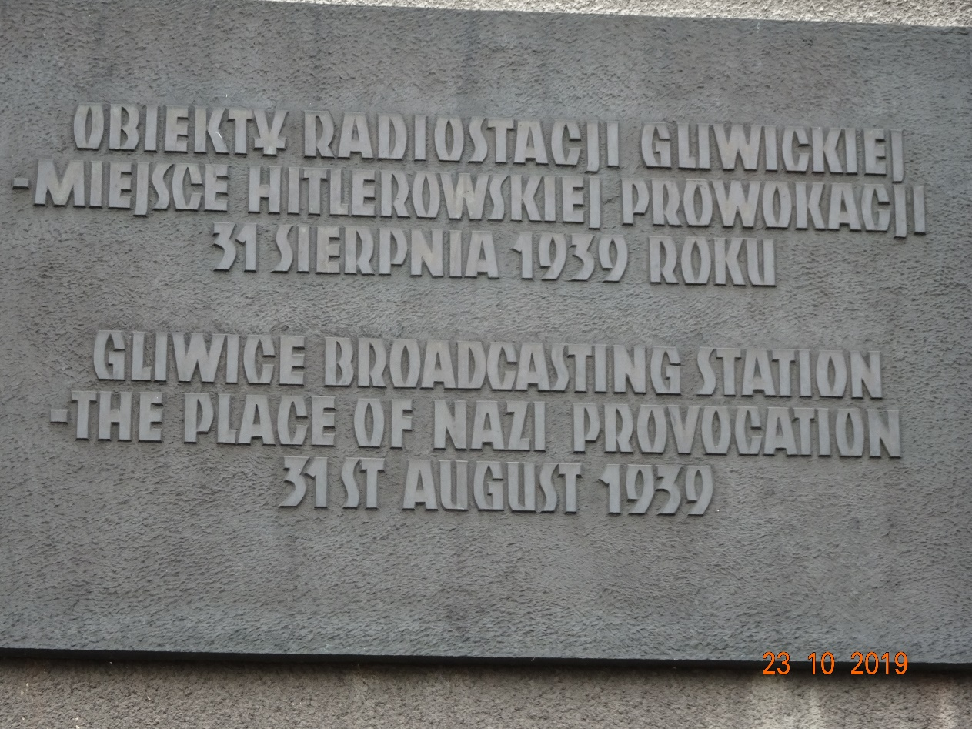

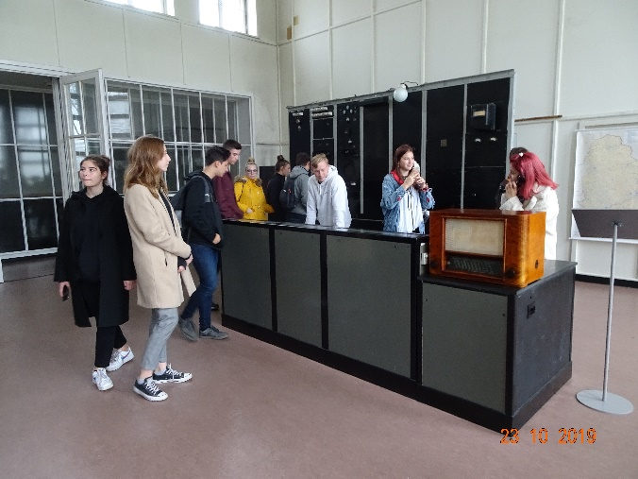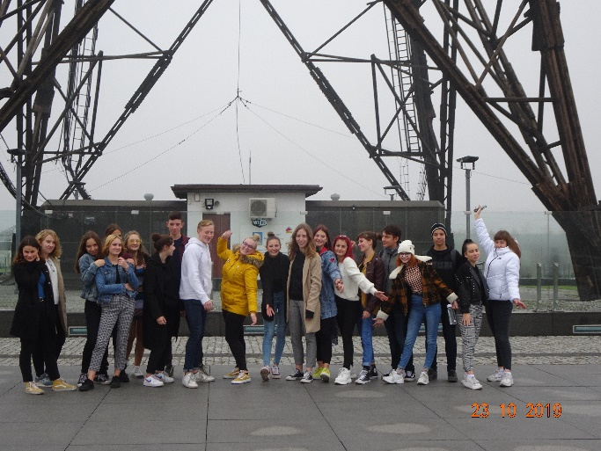

Obisk judovskega centra nas spodbudi, da razmislimo, ali je sovraštvo do Judov res stvar preteklosti.
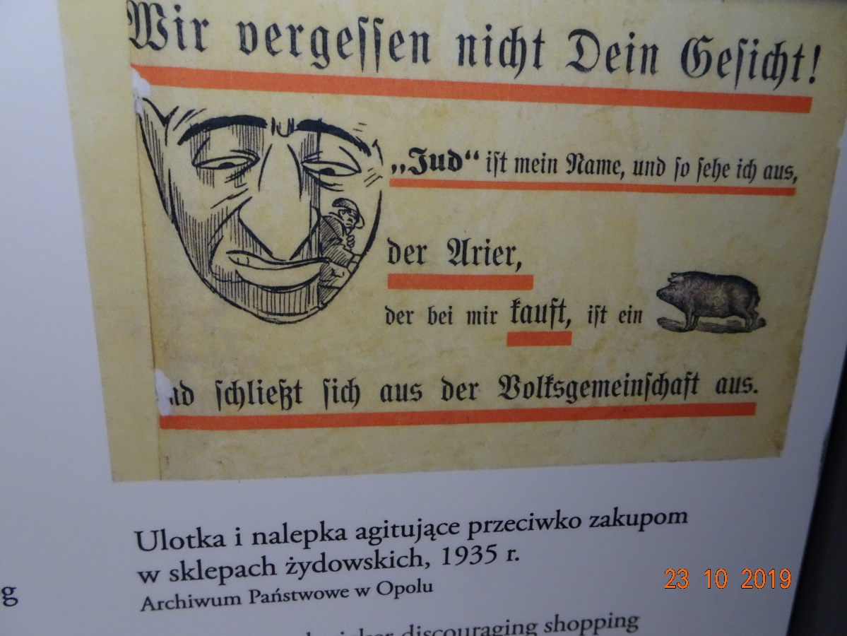
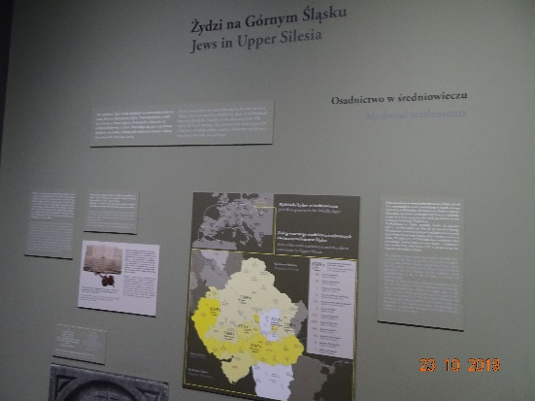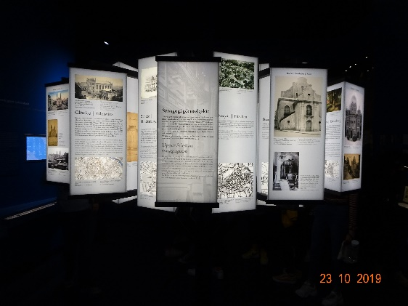
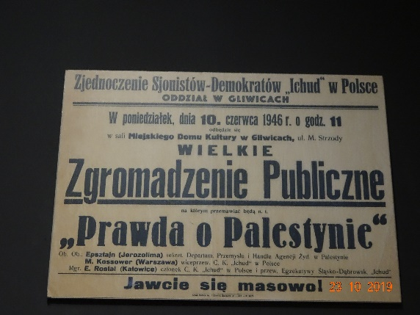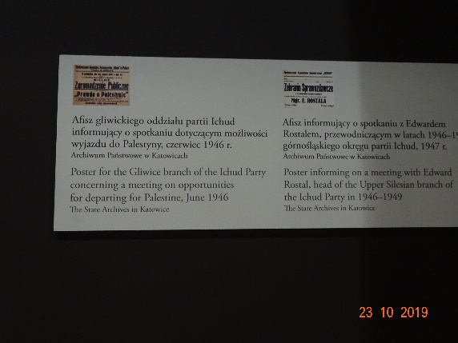

Četrtek, 24.10.2019 – Propaganda v poljski zgodovini
Katowice – Instytut Pamieci Narodowej – naš obisk je drugi iz Slovenije v dveh tednih, inštitut sodeluje s Študijskim centrom za narodno spravo, mi pa propagando spoznamo še podrobneje:
Answer the following questions before the workshop:
Explain what propaganda is and what its purpose is.
Characterise propaganda in totalitarian countries.
Explain the term the Katyn massacre.

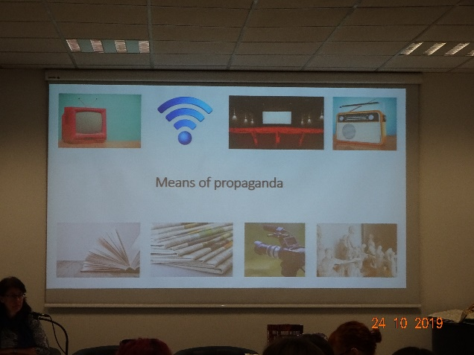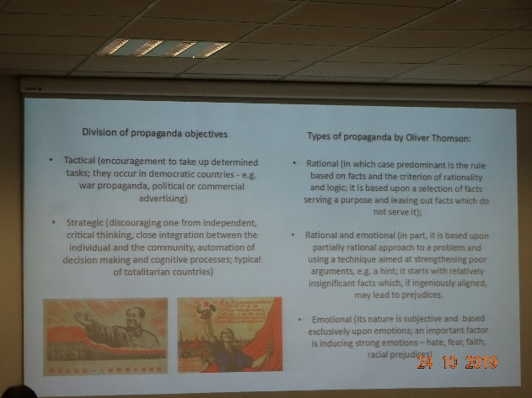
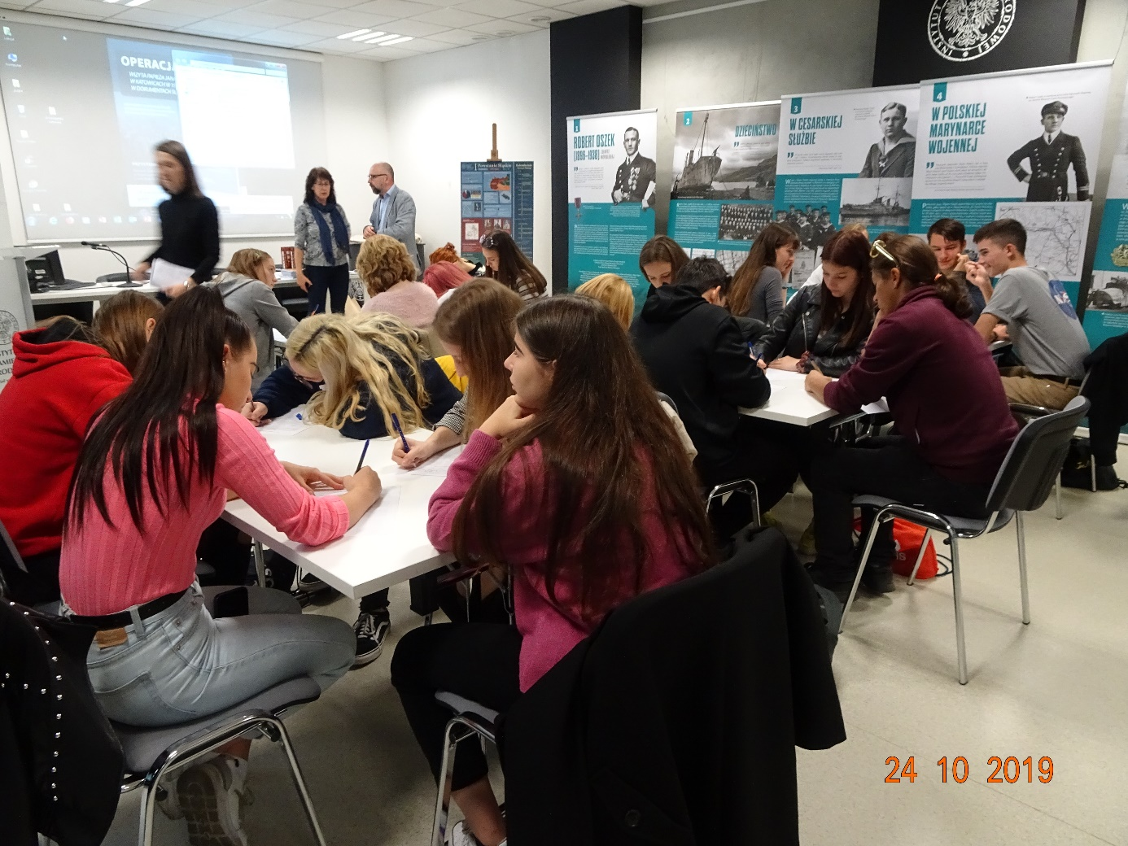

Answer the following questions after the workshop:
Explain how the aims of propaganda can be classified.
Present the tools of propaganda.
Explain the term the Katyn lie.
Compare the German and Soviet propaganda in connection with the discovery of the mass graves in Katyn.

Pred prihodom na Poljsko smo doma obiskali Muzej narodne osvoboditve v Mariboru, kjer smo si ogledali občasno razstavo Boj in trpljenje – Poljski državljani med drugo svetovno vojno, ki jo je pripravil Muzej druge svetovne vojne v Gdansku. Tam smo spoznali sovjetizacijo in germanizacijo Poljske. Inštitut na Poljskem nam predstavlja del boleče zgodovine, Katinski pokol, množično usmrtitev poljskih častnikov s strani Sovjetske zveze leta 1940.
Kdo so bili častniki?

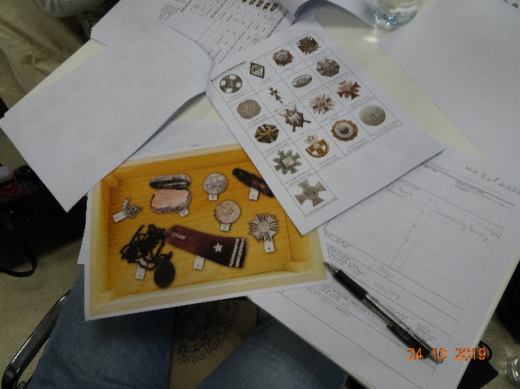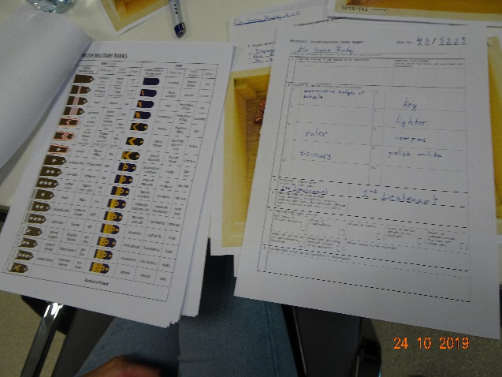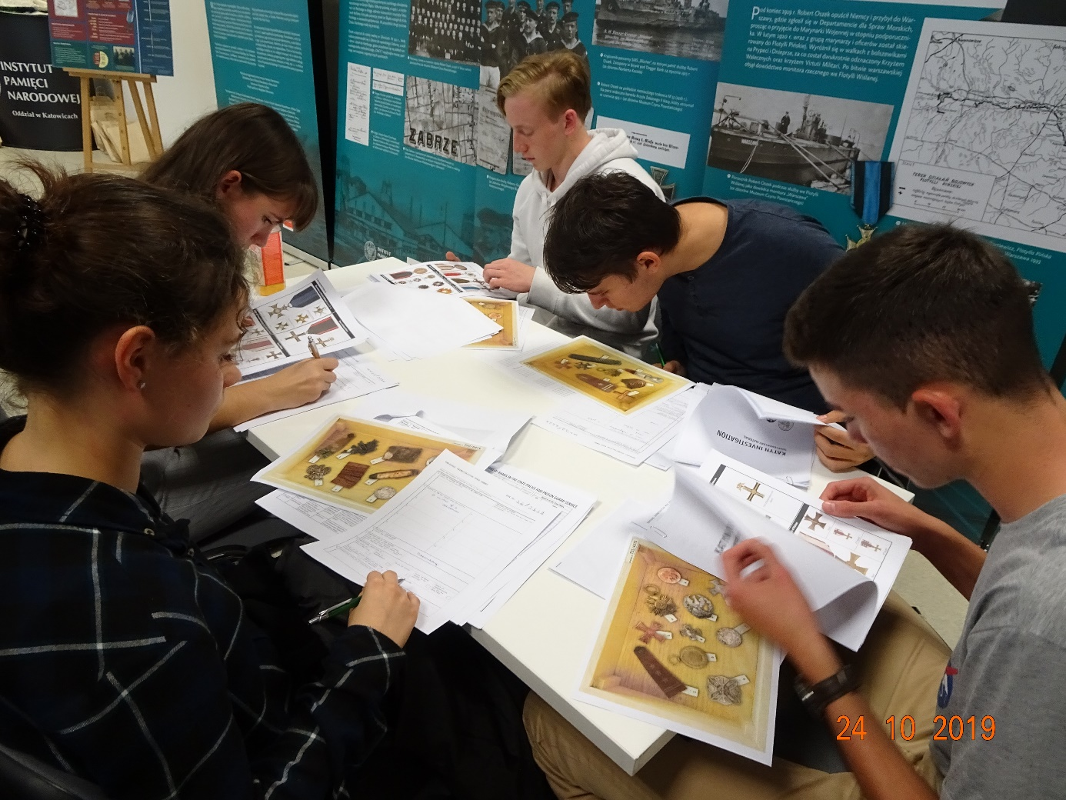

Petek, 25.10.2019 – Krakov, Schindlerjeva tovarna
Spoznavamo čudovito mesto, prijeten sprehod ob spoznavanju zgodovine mesta:
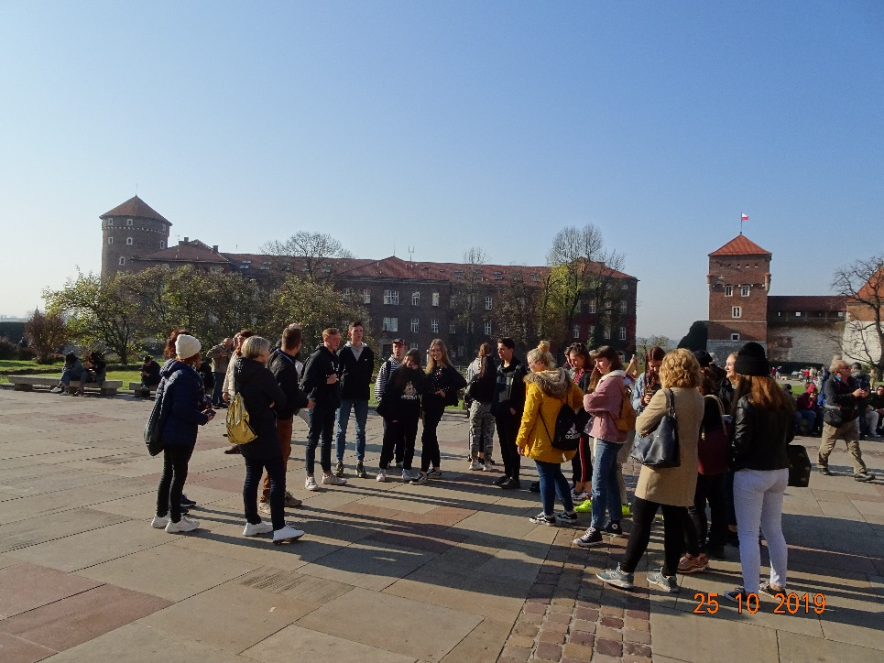
Vstopamo v Krakovski geto – Kazimierz:
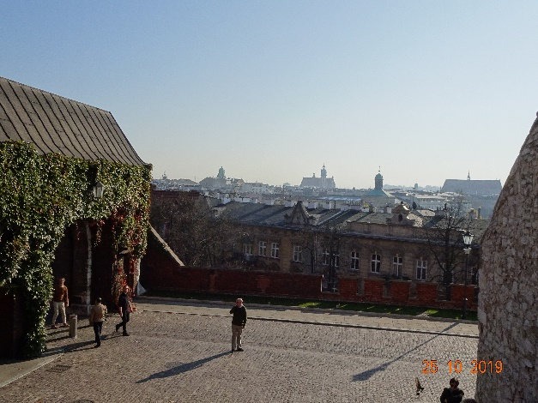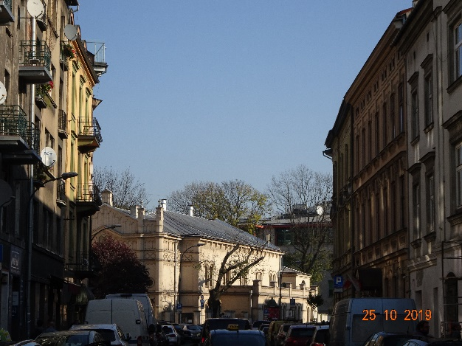
Pred obiskom Schindlerjeve tovarne spoznamo življenje v getu in judovske običaje, ustavimo se ob hiši iz znanega filma:
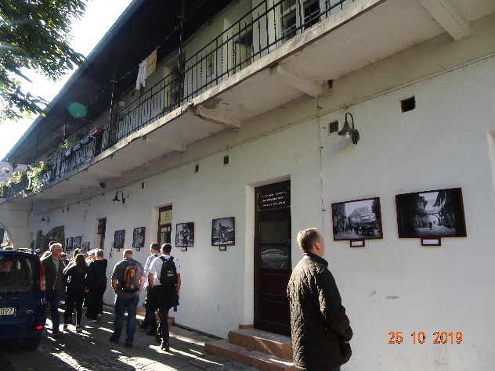

V Krakovu največ časa preživimo v Schindlerjevi tovarni. Spoznavamo življenje pred vojno in priprave na tragedijo:
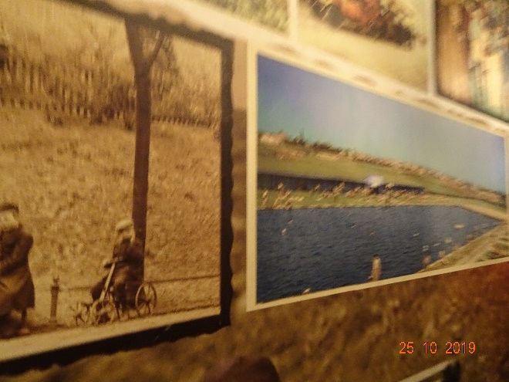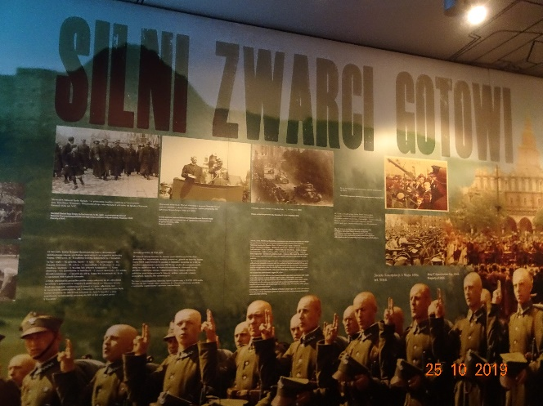
»The Strong«, »The Willing«, »The Ready«
Izbiramo plakate, prepoznati moramo tipične elemente, s čim poskušajo prepričati, manipulirati?
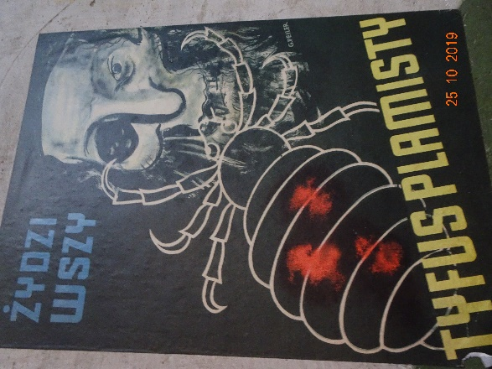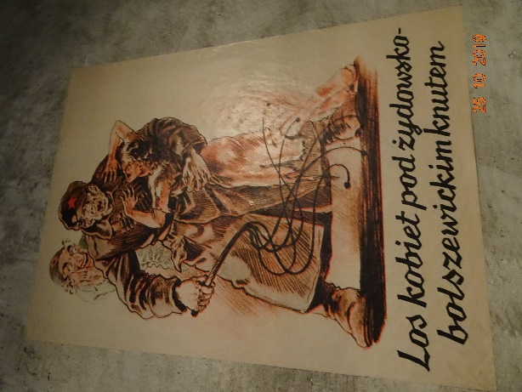
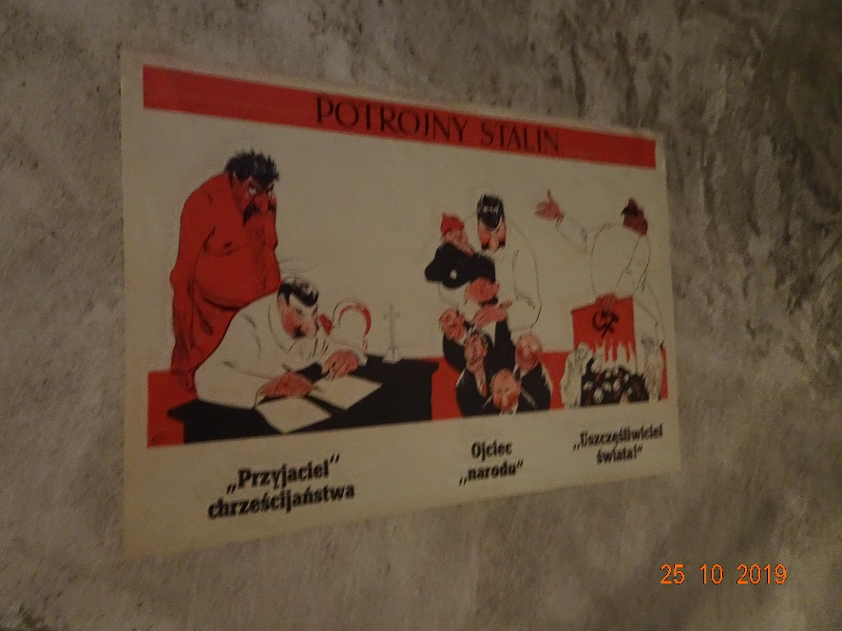

Naša pot raziskovanja se konča v »sveči«.
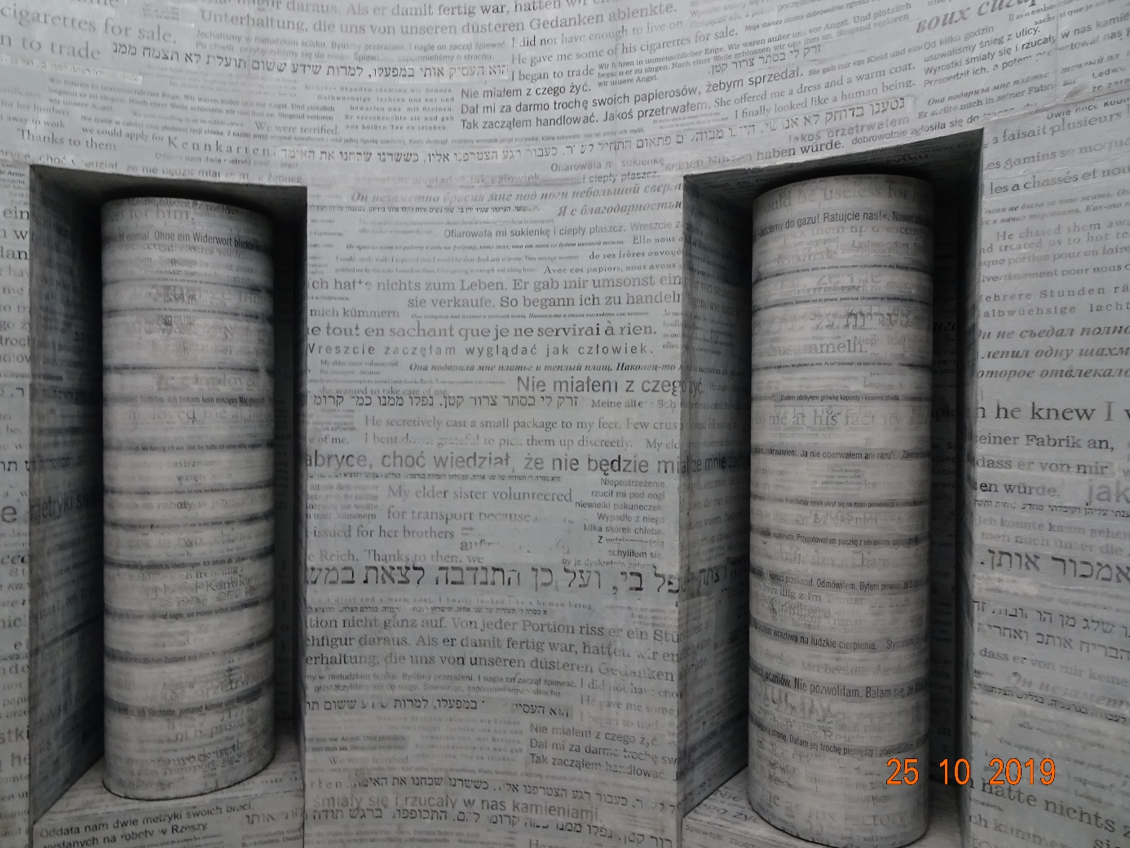

Stene so polne zapisov o pomoči, solidarnosti, človečnosti, ki so jih ljudje izkazovali sočloveku v času vojnih grozot.
Je siva, ker ni nič na svetu črno belo.

“Those who cannot remember the past are condemned to repeat it.”

George Santayana

