PROPAGANDA, PERSUASION, MANIPULATION

propaganda (noun) - ideas or statements that may be false or exaggerated and that are used in order to gain support for a political leader, party, etc.
persuasion (noun) - the act of persuading (making somebody do something by giving them good reasons for doing it) somebody to do something or to believe something
manipulation (noun) - behaviour that controls or influences somebody/something, often in a dishonest way so that they do not realize it

(Oxford Learner`s Dictionary)

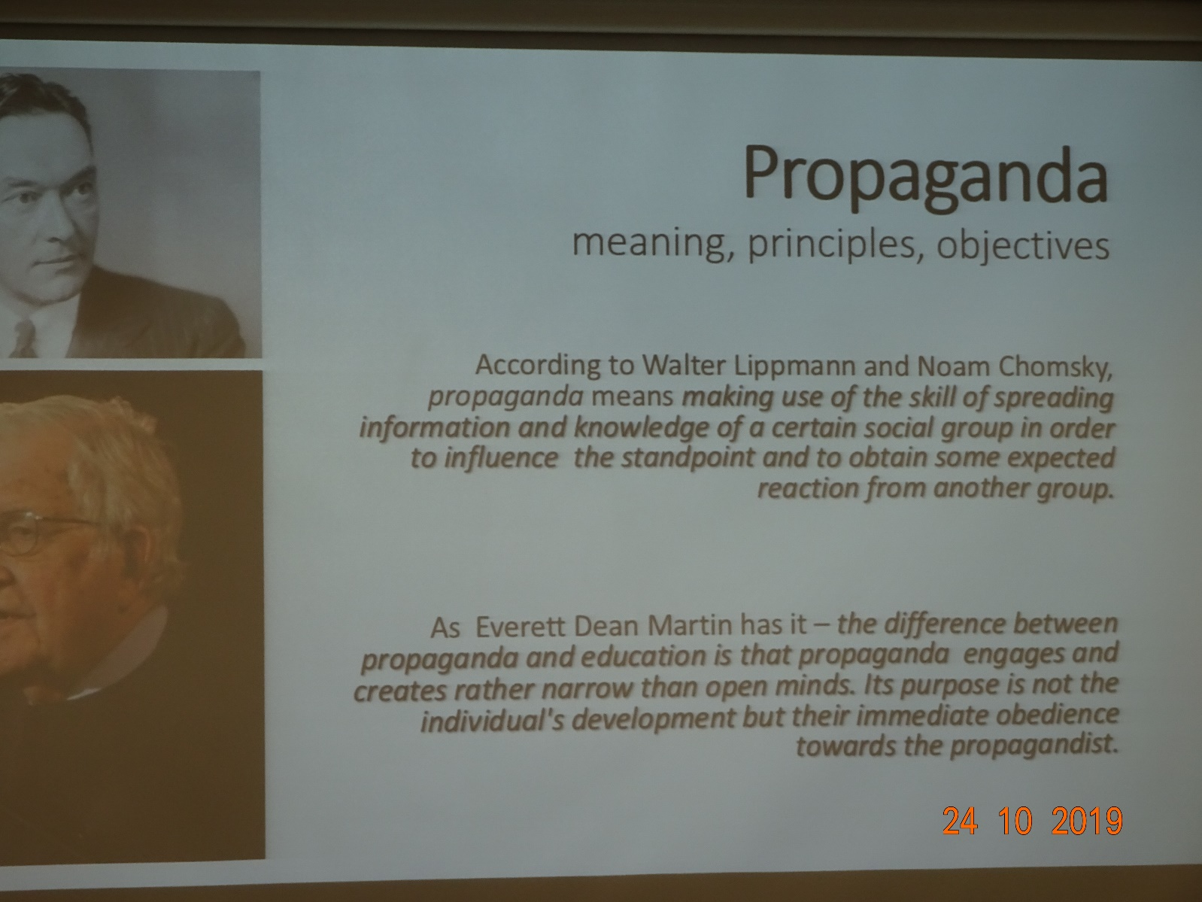
Propaganda is a form of communication that attempts to achieve a response that furthers the desired intent of the propagandist. Persuasion is interactive and attempts to satisfy the needs of both persuader and persuadee.

G. S. Jowett & V. O`Donnell

…………………………………………………………………………………………………………………………………………………………………………..

In Mein Kampf, Hitler established several cardinal rules for successful propaganda:
- avoid abstract ideas and appeal instead to the emotions;
- employ constant repetition of just a few ideas, using stereotyped phrases and avoiding objectivity;
- put forth only one side of the argument;
- constantly criticise enemies of the state;
- identify one special enemy for special vilification.

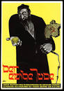
https://www.google.com/search?client=firefox-b-d&q=postrr+der+ewige+jude

A poster for The Eternal Jew exhibition held in the late German Museum IN Munich in late 1937. This is an archetypal caricature of a Jew showing of shekels in the right hand, as well as a map of the Soviet Union and a whip in the left. It did not seem to concern the German propagandist that these were contradictory symbols.
A film based on this exhibition was made by head of Nazi film production. It depicted the worst racial stereotypes and compared Jews to a plague of rats that needed to be exterminated.
(G. S. Jowett & V. O`Donnell, Propaganda and Persuasion, 2015)

………………………………………………………………………………………………………………………………………………………………..

………………………………………………………………………………………………………………………………………..
PROPAGANDA
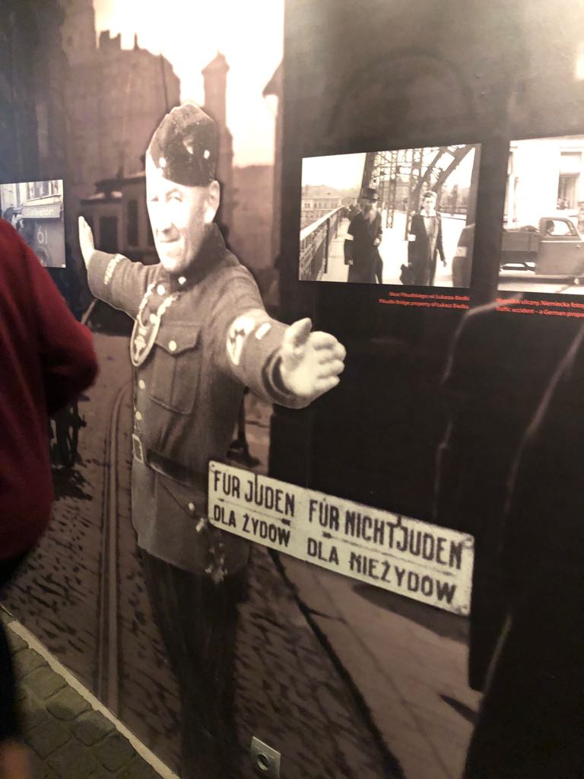
Propaganda is the spreading of information in support of a cause. ... The word propaganda is often used in a negative sense, especially for politicians who make false claims to get elected or spread rumours to get their way. In fact, any campaign that is used to persuade can be called propaganda.
In World War II was propaganda used to win the support of millions of Germans in a democracy and, later in a dictatorship, to facilitate persecution, war, and ultimately genocide. The stereotypes and images found in Nazi propaganda were not new, but were already familiar to their intended audience
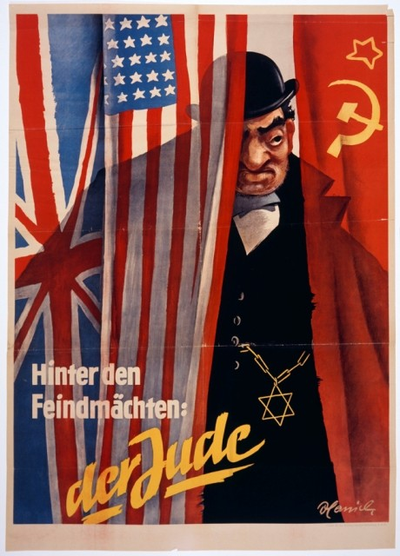

There were several audiences for Nazi propaganda. Germans were reminded of the struggle against foreign enemies and Jewish subversion.
Nazi propaganda talked about Jewish people, how they needed to be killed.

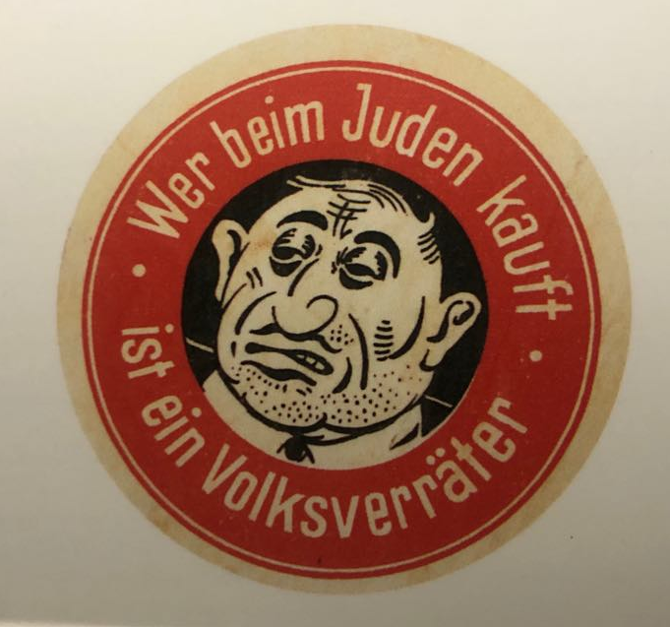
They have made everyone believe that Jews were not worth anything and they were bad for society back then.
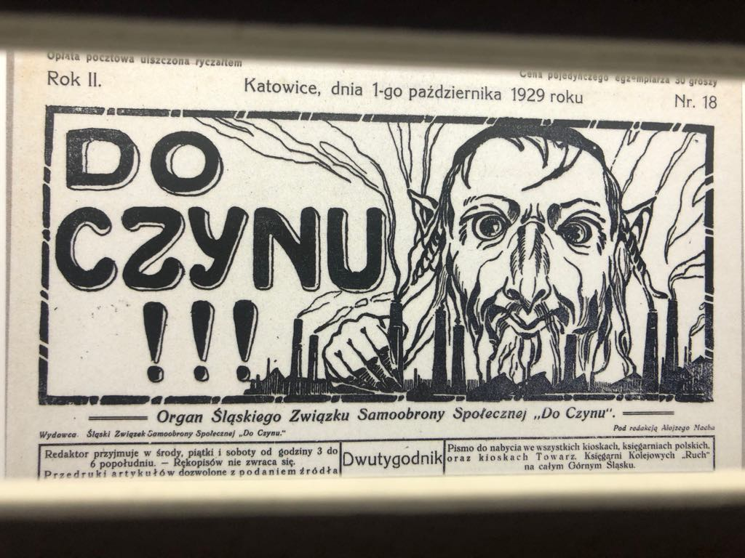
On posters they were shown in a bad manner as ugly people.

Jews were discriminated against. For example, there were different trains for Germans and Jews, different toilets, mostly everything different. They were classified as the lower class of society.

Mojca Kop

……………………………………………………………………………………………………………………………..
Propaganda poster
(Shindler`s factory- exchange to Poland 2019)

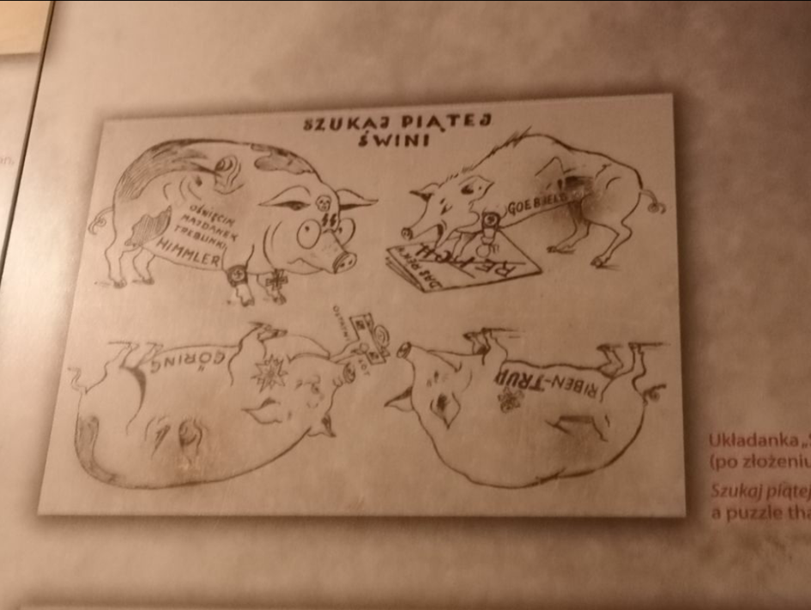
Goals of propaganda are to change people`s mindset and make them believe what you want them to. However, this poster was made to show how terrible German leaders were. In my opinion this poster is a tactical type of propaganda; it encourages people to take on hard tasks such as rebellion against the invader. I also think it aims at creating emotions in people such as hate. That`s why I would categorize it as emotional type of propaganda (according to Oliver Thompson). This propaganda poster was made by an anonymous artist during WW2 in Poland. There are 4 pigs on the poster each one represents one of main leaders of 3rd Reich. There is Himmler, Goebbels, Ribbentrop and Göring. There is one German Nazi leader missing in the picture and it`s Hitler himself. However, if you fold the four pigs you get his face. I really like this poster since it is so innovative and quite funny. Anyone who was caught using this poster during German occupation of Poland was executed.
Oliver Jayasinghe
………………………………………………………………………………………………………………………………………..
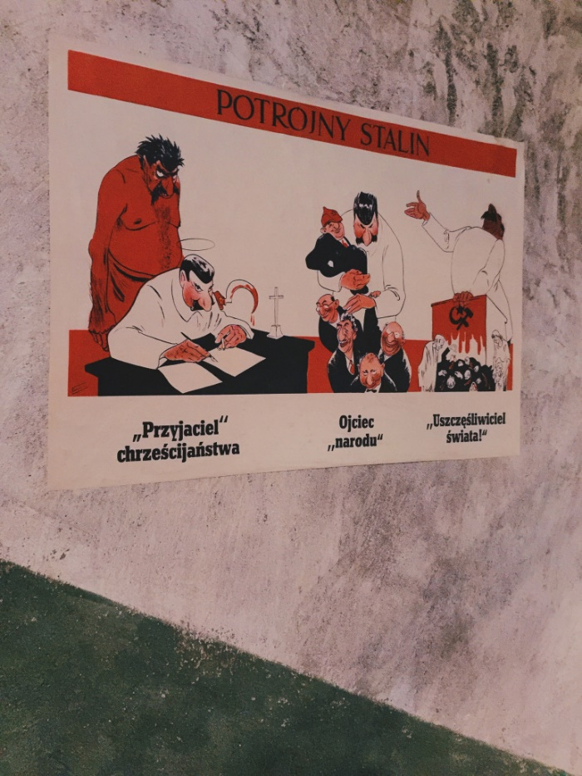
Propaganda is more or less systematic effort to manipulate other people’s beliefs, attitudes, or actions by means of symbols (words, gestures, banners, monuments, music, clothing, designs on coins and postage stamps, and so forth).
Propaganda wasn't only used by Hitler and Jewish nation. There was also propaganda in The Soviet Union. For example, the picture above shows how Stalin was looked at from different perspectives. It says he was a friend of Christianity. But was he really? A father to the nation, but only to the higher class and politics. And a world insurer to the poor. He never suffered such hatred as Hitler but still killed over 4 million people.
Propaganda manipulates youngsters better than elderly people. When using propaganda, it starts at the roots. The youth. It begins at schools or kindergartens. Then it moves on to music, books, movies - anything that affects the youngsters` thinking. When you’re already inside their head it’s hard to convince them otherwise. That is the tactic Hitler and Stalin used and it is shown to be very effective.
Today it is harder to manipulate people because of the free speech and thinking for ourselves.
Ema Finžgar

………………………………………………………………………………………………………………………………………….
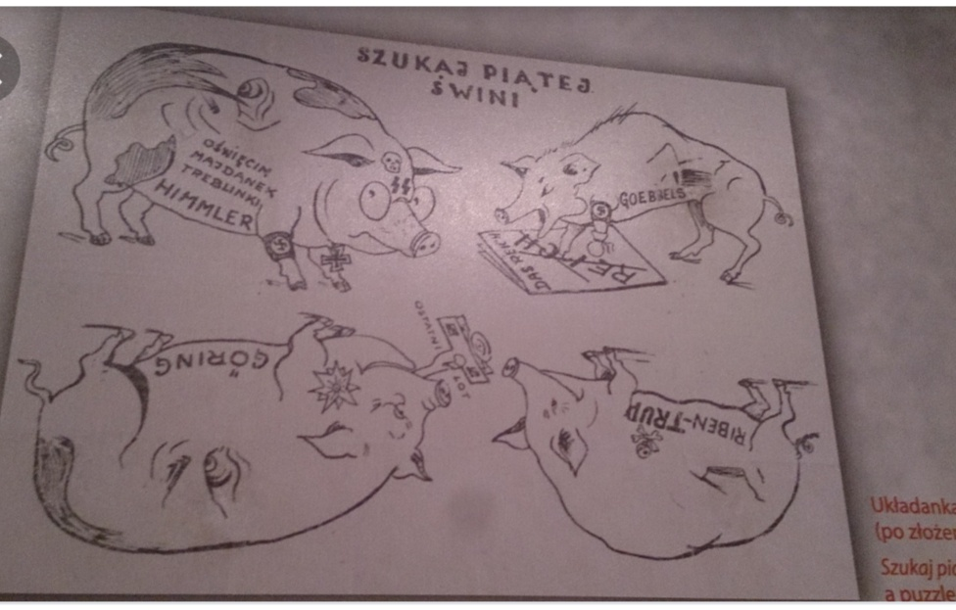
This is a Polish caricature which was made around 1942. It is called "Szukaj piatej swini", which means “Try to find the fifth pig”.
As we can see, there are five pigs with names of five German- Nazi political leaders: Himmler, Goebbels, Goring and Ribbentrop. And then there is a question who is missing? The answer is Hitler. But that is not completely true, because if you take a picture and you fold it right, you will be able to see the face of one of the leaders who was the beginner of the most terrifying war in the history of world , you are going to see the face of Adolf Hitler.
I think that the picture is so cleverly made and it presents the fight of the Polish civilians that couldn't fight the Nazi, because they were just too strong.
It is obvious that Nazis didn't like the picture so if they just thought that someone was connected to the picture he or she was immediately killed, no questions asked.
Luka Šahmanovič

……………………………………………………………………………………………………………………………………
Schindler's factory: Propaganda poster 29.10.2019 Ruše

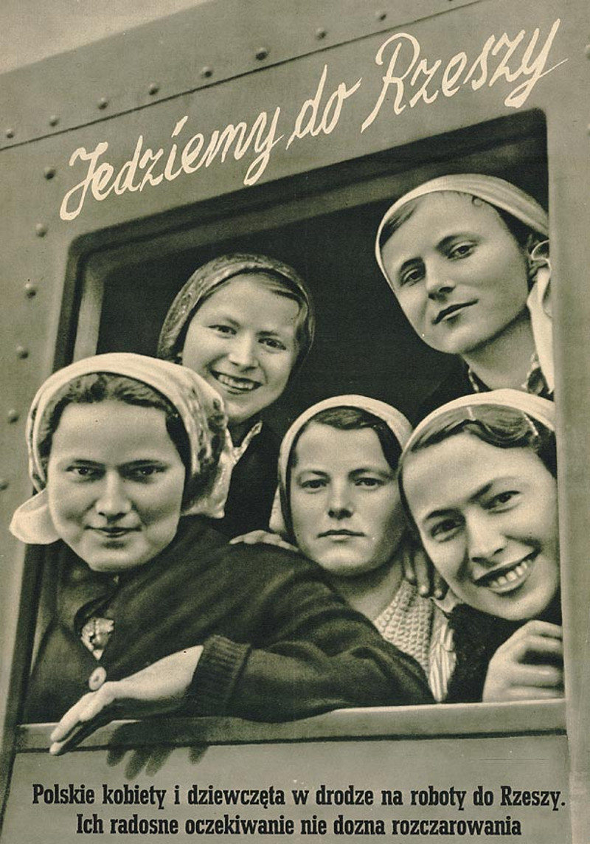
Before going to Schindler's factory we got an assignment to take photos of the propaganda posters. Then we had to choose one of those posters and translate the messages. Based on the meaning of the poster we had to evaluate and define which type of propaganda it represents.
In the poster I chose you can see five women on the train. Above their window there is a caption: Jedzemy do Rzeszy. Which translates to: We’re going to the Reich. Underneath the window, there is some added text which states: Polskie kobiety i dziewczęta w drodze na roboty do Rzeszy. Ich radosne oczekuwanie nie dozna rozczarowania. This translates to: Polish women and girls on their way to work at the *Reich. Their joyful expectation will not be disappointed.
Regarding the meaning of the text in the poster and the depicted image of happy Polish women going to work at the Reich I think that this poster was made by the German party (as were most) to try to persuade Polish people that going to work in the Reich isn’t anything bad and that it will provide them with a better future. In this advertisement, we can see an example of emotional propaganda because nothing depicted is confirmed by facts, it completely relies on emotions like hope and faith.
*Reich is also known as the Third Reich or Nazi Germany. Nazi Germany/Deutsches Reich was the formal title for the property that was controlled by Hitler and his Nazi Party (NSDAP), within the years 1933 and 1945.

Ela Ivana Rataj 2.aG
……………………………………………………………………………………………………………………………………………………………………………..

Modern propaganda uses all the media available – press, radio, television, film, the Internet, Facebook, Twitter, YouTube, e-mail, smartphones, videos, cartoons, posters, meetings, rallies, billboards, speeches, flags, monuments, street names, coins, stamps, books, plays, comic strips, music, rituals, sporting events, cultural events, awards, prizes…..

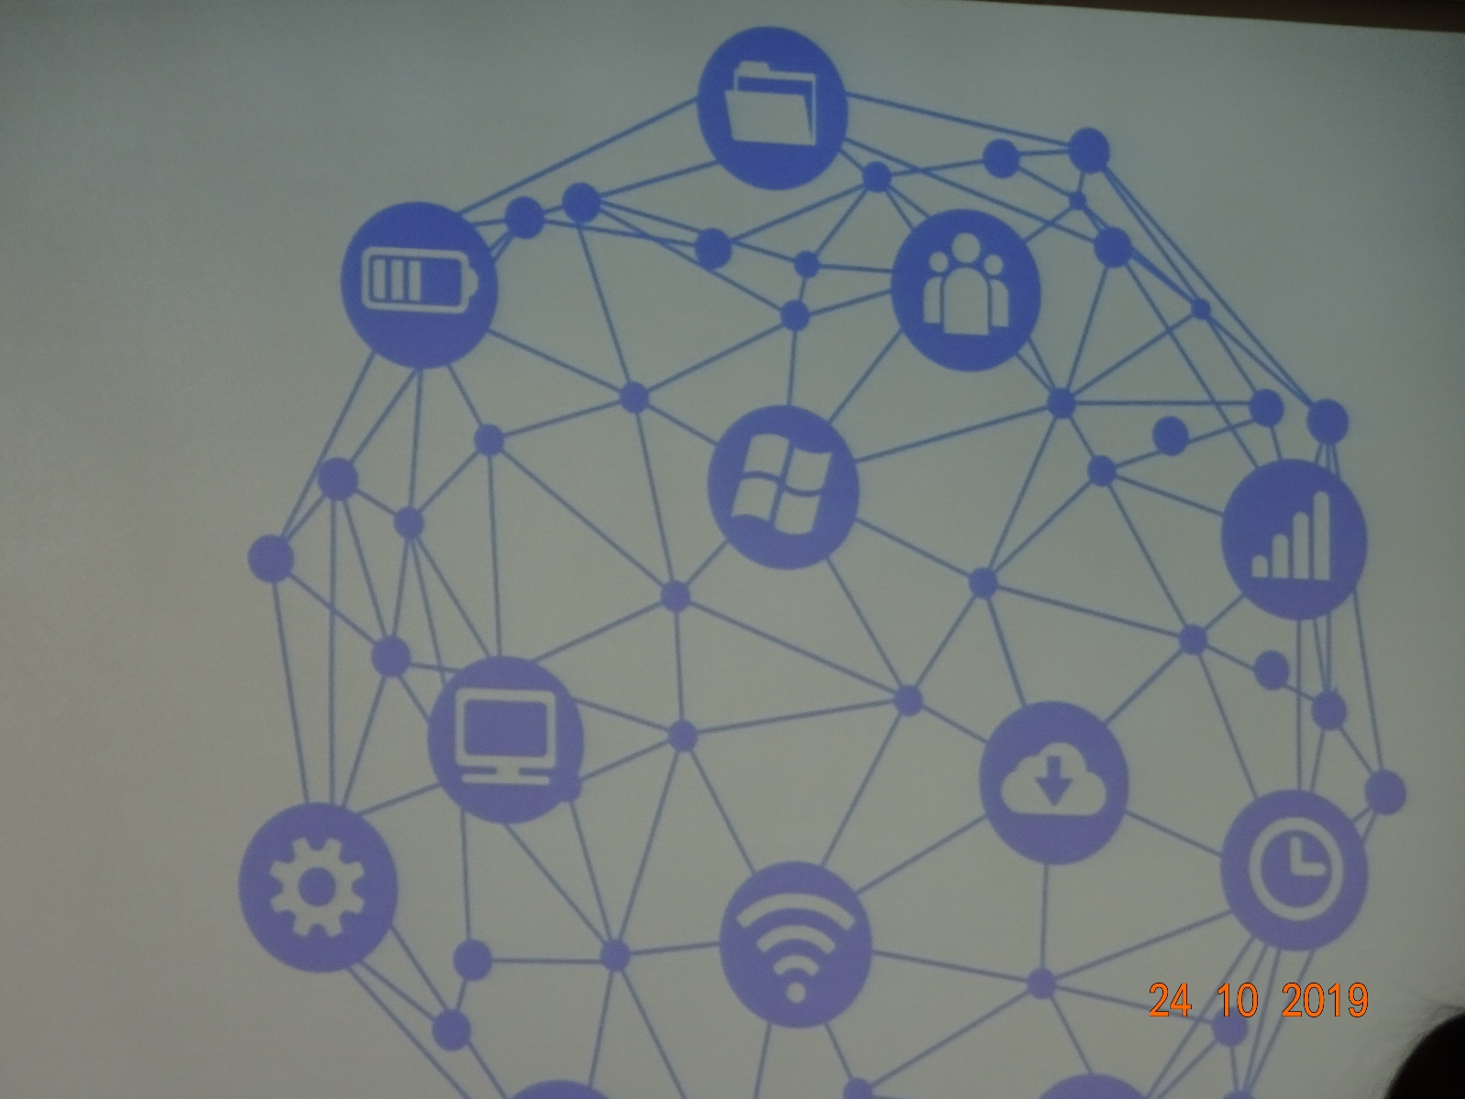

In this age of propaganda, we must defend ourselves. Here’s how
Natalie Nougayrède

Perhaps there are antidotes to propaganda that go beyond the necessary effort of checking what your sources of news are and making sure they are reliable. Citizens who live in an authoritarian, disinformation-filled environment deal daily with the reality of propaganda in ways we can’t fully experience, because we live outside it.
Most of us tend to focus on how disinformation spreads across our societies – the bots, the trolls, the technological machinery of “fake news”. We spend perhaps too little time thinking about the very essence of propaganda: the ingredients that go into a dish meant to captivate us, play on our emotions, and control what we think. If you are able to break those ingredients down, you become less vulnerable.
In the late 1930s, an American professor at Columbia, Clyde R Miller, drew up a list of criteria that he believed defined propaganda. The young people I met had fun identifying these ingredients among examples of what their state media and politicians constantly spew out to the public. The more I listened to them, the more I thought: we need this to be taught or shown to young people across our democracies. Developing resilience to propaganda can’t be done only through denouncing it, or just by creating fact-checking mechanisms or websites that debunk “post-truth” – however useful and necessary those efforts are. Providing the tools to identify propaganda assists action upstream, before it even starts exerting its influence. First, there’s the “name-calling” propaganda that systematically attaches labels to what it wants to condemn, forming its judgments without examining any evidence and with labels to match: “fascist”, “red”, “terrorist”.
Next come the “glittering generalities”: propaganda that strives to associate itself with shining ideals whatever the contrary evidence. It suggests that if you’re good and virtuous, you will believe it. Then there is “transfer”: propaganda that carries over the authority and prestige of something we respect to something it wants us to absorb – in Russia, for example, the “great patriotic war” and Vladimir the Great are constantly recycled. Add to that the “testimonial” device: propaganda that seeks to secure approval from prominent names, or “useful idiots”, confident that people will follow a leader.
Utilising the “plain folks” device, propaganda strives to sound and look like something common, close to the people, which can include vulgar language, or an anti-elitist slant: it’s one of us. There’s “card-stacking”; when propaganda selects only those sets of facts that support its assertions, and then the “bandwagon” device. Follow the crowd, it says: everyone thinks this, so why stand out?
We could add “whataboutism” to the list: the art of minimising negative aspects or crimes (such as the bombing of civilians in Aleppo) by pointing to what others have done elsewhere (the US army in Iraq, or discrimination in the US). Lumping everything together feeds confusion and indifference.
Last year, in a study of organised social media manipulation across 28 countries, two Oxford academics made this observation: “Every authoritarian regime has social media campaigns targeting their own populations, while only a few of them target foreign publics. In contrast, almost every democracy has organised social media campaigns that target foreign publics, while political party-supported campaigns target domestic voters.”
“Propaganda” rears its head in so many countries in so many ways. It reached unprecedented prevalence and refinement in the totalitarian regimes of the 20th century. Now it’s a new normal in Russia, Turkey and arguably Poland, all states that have experienced various stages of democratic backsliding in recent years.
The use of propaganda is ancient, but never before has there been the technology to so effectively disseminate it, and rarely has the public mood been so febrile. If identifying lies and distortions was desirable before, isn’t it now essential self-defence?
https://www.theguardian.com/commentisfree/2018/jan/31/propaganda-defend-russia-technology

